Course Code: COMP 4602A

Social Network Report

Group: Undergraduate 16

Name: Leo Xu, 101149896

Andrew Hall, 101156505

Spencer Low, 101114608

Date: April 17, 2024

**Abstract**

This paper dives into the intricate web of social relationships that emerged during the second season of *The Island with Bear Grylls*. The paper focuses on the dynamic interplay of interpersonal connections in high pressure situations of survival. Our analysis goes in depth into the formation and evolution of social networks of these British men and women. Through the exploration of these networks, our aim is to mainly unveil predictive patterns of group cohesion, social dynamics, and discern emergent factors of leadership traits. Our findings highlight the pivotal roles of participants with high degree and betweenness centrality. It also indicated that negative relationships between certain participants highly corresponded to lower clustering coefficients and deteriorating group bonds, which not only indicates the potential for a participant to leave a group but reflects in the groups performance overall. In essence, the study provides valuable insights into the intricacies of social networking dynamics within extreme environments within isolated communities striving for survival.

**Introduction**

This paper aims at studying the various social relationships that were formed during season 2 of *The Island with Bear Grylls* from the perspective of social networking related to graph theory and network science. *The Island with Bear Grylls* is an episodic television show focused on the journey of ordinary people trying to survive together on a tropical island for 6 weeks. The second season of the show provides a unique sample population as it focuses on 14 British men and 14 British women who are marooned on separate islands split by gender. Our primary goal is to explore how different social networks are formed and evolve over time in a situation where survival strategies and group dynamics along interpersonal relations are impacted by extreme environments in high pressure situations. Through analysing these networks we are hoping to identify patterns that can predict group cohesion, highlight social dynamics and identify emergent leaders.

**Related Works**

*The Island with Bear Grylls*, provides a reasonably accurate representation of how an unfamiliar and isolated population would engage in resource management and survival. The participants of the show must record themselves in their entirety and highlight a demonstration of survival strategies and tasks while also underscoring the importance of social dynamics, leadership roles, conflict resolution, and cooperative efforts within a group. To understand the dynamics of resource management, it can be through observing how groups locate, share, and conserve resources in the beginning and through the rest of the season. This includes finding water, creating fire, food, and shelter. Tracking the development of these vital processes from their arrival to extraction, and documenting changes in behaviour within groups will be how we will answer our research question.

**Background necessary**

In order to accurately represent and analyse how social networks influence group dynamics in extreme environments several different concepts related to network science and graph theory must be used. An early indicator that can be used to see if a person has the potential to be a leader in a group can be seen through a node's degree or degree centrality. A node's individual degree refers to the number of distinct edges that it has, the more edges a node has the more important it is inside a network. In conjunction with a node degree, a graphs betweenness centrality can be used in order to determine how important a node is in regards to the flow of information/communication. Betweenness centrality essentially represents the number of shortest paths going through any given node and is calculated by summing the number of shortest paths running through the entire network and then counting how many paths pass through any given node. Clustering coefficient measures the proportion of a node's friends that are also connected to each other and is important as it can be used to determine the degree of closeness different individuals in a network have and highlight the formation of smaller networks within larger ones. The density of a network can be used to measure the level of connectivity within a network, it is calculated as the number of edges in the network out of all the possible edges. Through leveraging network density it is possible to see cohesion or fragmentation within networks and studying its change over time can infer useful information of a networks success and dynamics.

Although *The Island with Bear Grylls* is linear in nature, the show's episodes focus on either the male or female island independently. On the surface it may appear that the show alternates between the two islands uniformly, both episode 8 and episode 9 focus on the female island. As such in this paper whenever an episode is referred to the episode number of the show and whether it was the male or female island will be stated.

**Data**

A dataset was constructed cataloguing interactions between individuals. In season 2 of *The Island with Bear Grylls*. This was achieved by filling in an excel sheet with all the interactions between characters that were observed through watching the show. The data set consists of important information like the timestamp of each interaction, who the acting and receiving character(s) were, along with a description of the actions that occurred and a recording of whether the interaction was a positive, negative, mixed, or neutral interaction represented in a numerical format. Positive interactions were categorised as anything friends would do normally together. Examples include people laughing, teamwork, compliments, communal dining, physical touch, etc were all attributed as positive interactions. Instances of negative interactions were recorded when people had unfavourable encounters. Examples of this would be if there was a Negative argument, disagreement, fighting, or talking behind an individual’s back. Mixed interactions are on the more complicated side with interactions having both positive and negative implications when several people interact at the same time. In order to represent the data as accurately as possible, the effect of various actions were recorded on an individual to individual level. Neutral interactions refer to when there is minimal to no emotion or significance within an interaction. Examples of this are when people are not speaking to others in a scene because they are just listening. The valence of these interactions is 0 as no one was affected. In the dataset, most neutral interactions were not recorded, since they provide no significant change to the bonds of the group and would needlessly clutter the information. Accurately representing the feelings of people from interactions is however difficult since we do not always know what is going on inside people's minds, as such the data in the dataset is not entirely accurate but provides a good representation of the relationships between individuals based on significant events. The data shows the character's overall relationships and feelings they have for the other characters based on all the positive and negative interactions they had from the start to the end of each episode. The dataset was used in order to graph the individual's changing relationships during the show.

**Model**

The constructed dataset from the show is a collection of complex interactions between members within two different survival groups, and it shows how actions will affect how others collectively or individually perceive an individual's worth to the group's overall well-being on the island.

Through graphing the total interactions and valence in relationships, for each group per episode, metrics from the network such as centrality, connectivity, and clustering coefficient emerge and will assist with the analysis and understanding of the relevancy of the social relationships and dynamics formed throughout the season. This is because they help categorize specific individuals based on their importance within the group, assess the overall group and individual cohesion, and identify subgroups that may emerge within the overall social network.

These patterns such as interaction among participants, knowing which individuals are influential, and understanding the level of cohesion within the survival groups throughout the series may allow the prediction of changes in group dynamics over time, which will help with the objective of understanding how social networks influence survival strategies and group dynamics in extreme environments. These insights gained from modelling will help explore how to enhance group cohesion, improve decision-making processes, and improve overall survival outcomes in challenging environments like those depicted in *The Island with Bear Grylls.*

Examining human behaviour in extreme circumstances in combination with modelling social networks significantly contributes to a better understanding of individual roles and how leadership behaviour affects the outcomes in challenging environments.

Through modelling, it becomes clear why the men’s island has found far more success with fewer hurdles. The men had more members taking initiative, had multiple members step up into the leadership role, and as a result, were tightly cohesive early into the show. Unfortunately, the women's group had splintered into an expedition group and a camp group, a mistake that would have lasting negative effects on the group cohesion until late into the show when they finally elect a singular leader among the group. This is evident when in the show there is a lack of communication and leadership among the women compared to the men's group, and as a result, they had deficient access to food and water supply, on top of an unmaintained fire that quickly extinguished very early into the show. This did not happen with the male group, and the analysis supports this as the men resolved their problems early and increased their cohesion, which allowed them to communicate their roles and prioritize urgent tasks. Proving that in survival situations through social networks, a key to improving chances in extreme situations is to keep a group together as a unit.

**Methodology**

The project's foundation started with the analysis of season 2 of *The Island with Bear Grylls.* In order to accurately breakdown and model the show's information a transcription of the dialogue for each show's episode was required. Since *The Island with Bear Grylls* did not have any subtitles a transcription had to be generated. This was achieved by converting each episode into an audio file and then generating draft transcripts through a combination of OpenAI's Whisper and Pyannote-Audio, which was achieved through Pyannote-Whisper. This integration enables us to leverage Whisper's translation capabilities and Pyannote-audio's speech diarization abilities, a process replicated for each episode of the show's second season.   
Example of the code and github libraries can be seen below:

%pip install pyannote.audio

%pip install git+https://github.com/yinruiqing/pyannote-whisper.git

%pip install git+https://github.com/speechbrain/speechbrain.git

import whisper

from pyannote.audio import Pipeline

from pyannote_whisper.utils import diarize_text

pipeline = Pipeline.from_pretrained("pyannote/speaker-diarization-3.1",

use_auth_token="AUTHTOKEN_PLACEHOLDER")

model = whisper.load_model("small.en")

asr_result = model.transcribe("S2EP1.wav")

diarization_result = pipeline("S2EP1.wav")

final_result = diarize_text(asr_result, diarization_result)

for seg, spk, sent in final_result:

line = f'{seg.start:.2f} {seg.end:.2f} {spk} {sent}'

print(line)

The generated transcripts were then manually reviewed while watching each individual episode in order to fix errors in the dialogue and assign each sentence accurately to the corresponding speakers within the episodes. During this manual review conversations were properly segmented and significant events were written in bold. To analyse the interactions that the characters had among each other, the transcripts were manually spaced out for each conversation/interaction that occurred. This process provides accurate transcripts along with a clear distinction of the people involved in each conversation and is a simple way of creating a complete overview of conversations during each episode. This method prepares quantifiable information that can be used to reveal any interaction patterns, positive or negative relationships within the group, individual standings within the group hierarchy, and the distribution of activities among members per episode. After completion of all the transcripts, their contents were compiled into a summarised Excel sheet for each episode. These sheets index every important interaction that portrays a noteworthy exchange between individuals. A large emphasis was placed on positive or negative exchanges as they have the largest demonstrable impact on relationships. After completing the excel data Python functions were written in order to properly update, change and store the relationship values as edge weights between each node inside a dictionary structure. An example of one of the entries inside the dictionary is "WEp2":{ 'LAUREN': {'FI': 1, 'JULIE': 1, 'BELINDA': 4, 'LAUREN': 0, 'BETH': 6, 'GEORGINA': 0, 'CHAVALA': 2, 'BEKI': 3, 'GEORGIE': 0, 'JAMIE': -1}...}. This data represents the graph node “Lauren” in the second episode of the show. The internal key/value pairs signify the edge weights between “Lauren” and that of other nodes inside the episode 2 graph. This dictionary structure was chosen as it provided a human readable format that allowed for easy manipulation and manual review. After converting all the data from each episode into the dictionary, all of the dictionaries' contents weights were compiled to form one large graph for each individual island spanning the length of the entire show. Upon completion of the excel data conversion the dictionary data was then stored in graph forms and saved into arrays. The aforementioned creation of the episode transcripts and manual partitioning of conversations into distinct segments also allowed us to generate interaction graphs for each individual based on who they spoke to inside each episode of the show. A Python script was used to read in each line until an empty new line was reached. This was our marker signifying that the end of a conversation or interaction had occurred. An edge was then created between individuals who participated inside an interaction for the first time in any given transcript file and stored in the same style of dictionary as seen above. All subsequent times the individuals interacted with each other the weight of the edge was increased by 1. This was done for each episode individually and saved as a NetworkX graph, then all of the elements in the interaction dictionaries were summarised for each individual island and saved in the same manner as the relationship dictionaries. Through the use of the open source Python libraries NetworkX and Matplotlib we were able to create and visualise each of the different graphs and visually compare and contrast the evolving relationships and structure of the networks.

**Results**

**Degree Distribution**

Through studying and ranking the degree of individuals inside our interaction datasets it is possible to predict the structure of network graphs and formation of leaders. This is because in a graph that represents the number of interactions individuals have nodes with a higher degree are more socially connected. Since these higher degree nodes have more connections they have the potential to exert more influence within a group of people and their actions can have a large impact. In the interaction graph Figure 3.1 from the first episode on the male island there are several nodes of potential interest that can easily be identified by their degree. Paul features the highest node degree of 12 and Vic, Andy and Joe feature the next highest degree of 11. In the interaction graph of the show's third episode Figure 3.2 the degrees shift. Vic ends up with the highest degree of 12, Joe falls down to a degree of 2, Paul's degree drops to 11 while Andy’s degree of 11 remains the same. Even without making large speculations it is easy to identify from just the two graphs that Joe no longer holds the same status he did before, and that Paul, Andy and Vic are finding their status within the group. This closely mirrors the events of the show, as during these episodes Joe quickly loses his standing with the others and leaves the island. Paul and Andy are both builders in real life and bring important knowledge to the table while Vic is a very resourceful hardworking man, three nodes with strong leadership potential.

It is important to state however that a node's degree is not the sole determining factor on whether an individual in a network is important or not. The important leaders are in some instances much harder to discern with just the degree alone. A great example of this can be seen on the woman's island in episode 2 of the show. In the interaction graph Figure 4.1 Beki has the highest degree of 13 and Jamie, Abby and Belinda have the next highest degree of 12. Although Abby is something of an authoritative figure on the island and Belinda is the group's doctor and both could be said to be potential leaders in the group, Beki and Jamie do not have any particular traits that would classify them as leaders. The interaction graph from episode 4, Figure 4.2however does correctly highlight potential nodes of interest with Kate’s node sporting a degree of 10 while Fi and Julie have degrees of 8. In this part of the show Kate and Fi both lead a group of women searching for a freshwater source while Julie leads the group of women who have remained to watch their original base.

The degree of a node inside a graph can act not only as an indicator of the most socially connected or influential people within their perspective groups but can also signify how connected a network is overall. The average degree of the interaction graph for the men's island in the first episode, as seen from the table in Figure 5.1 is 0.670, this means that on average the nodes of the graph are only moderately connected to one another, the bonds between all of the nodes can not said to be strong. This low average degree centrality follows the contents of the same episode. Since everyone had just arrived on the deserted island they can be said to largely be strangers and as such there is a lack of unity within the network. We can however see from the table that as the show progresses and the group's teamwork gets better the average degree centrality of the network increases. The final episode of the men's island ends up with a degree centrality of 0.955, an increase of 42.5% highlighting how much more interconnected each individual on the men's island has become. The women's island follows this same logic, as seen in the woman’s average degree centrality table Figure 5.2. The graph of the women's island in episode 2 has an average degree centrality of 0.714. As the show progresses the women's teamwork ultimately improves and their average degree centrality increases to 0.933, a 30.67% change.

**Betweenness Centrality**

The betweenness centrality can provide important information about nodes in a network, particularly on how information spreads and can facilitate the detection of different sub communities within a network. A relationship graph that only contains the highest weighted edges of each node allows you to gain a good visual representation of the social dynamics within a group. If you compute the betweenness centrality of the aforementioned graph the nodes with a high betweenness centrality not only represent bridges of information but also allow you to determine who is the most well liked in a given group. The betweenness centrality of each node in the graph from Figure 8.1 places Lauren at the highest with a value of 0.8205, followed by Georgina at 0.5256 and Georgie at 0.2820. This mirrors the events of the show with Lauren, Georgie and Georgina rarely appearing in any negative interactions acting as connecting links between other members. Interestingly enough Lauren was actually elected as a leader on the female island and we can see that her positive relations with the group likely influenced this. On the Men's island in Figure 8.2 you can see Barney has the highest betweenness centrality of 0.8974 with Dan following behind with a value of 0.4102. Barney is clearly identifiable as the friendliest overall member of the group. Unfortunately the men did not verbally elect a leader during their time on the island but both Barney and Dan are good examples of unspoken leaders within the group.

**Clustering Coefficient**

Since the clustering coefficient of a graph measures the degree to which nodes in the network tend to cluster around each other, it can be used as a good indicator of how cohesive or cliquey a network is. The average clustering coefficient of the men's interaction graph can be seen in the table Figure 6.1. The first episode in which the men meet as seen in Figure 3.1 has an average clustering coefficient of 0.8558, the next time the men are shown in the episode the average clustering coefficient has been reduced to 0.8188 a decrease of 4%. This means that the group's bonds have gotten worse and there are some individuals that either do not fit into the network or are actively deteriorating relationships. Although the reason for this is not easily apparent from looking at the men’s interaction graphs, their relationship graphs reveal that tensions between some members are indeed high. Participants like Paul and Andy are seen interacting heavily together in episode 1, but in Figure 1.1 their two nodes are spaced far from each other and the red-dotted line indicates that they currently share a negative relationship. This issue is only further exacerbated in episode 3 (Figure 1.2) where both Paul and Joe clearly have negative relations with most members of the group. If we look at the individual clustering coefficients in interaction graph nodes for episode 1 the two nodes with the lowest clustering coefficient are also Paul and Joe with clustering coefficients of 0.7121 and 0.6545 respectively. In a high stakes survival situation individuals who put the group at risk are highly detrimental. The best option for a network to survive would be to cut off the nodes that are causing trouble and are least integrated. The show mirrors this as early in episode 3 both Paul and Joe end up leaving the island. Later on in the same episode Andy, whose clustering coefficient has now dropped to the lowest in the men's group from 0.8181 to 0.7090 also leaves the island. With this change, the clustering coefficient of the group has increased to 0.945, a change of 15.43% as seen in the interaction graph Figure 3.3. Through the removal of the weakly connected group members Paul, Joe, and Andy the group has become a lot more stable and contains a significantly less number of negative interactions as shown from the relationship graph in Figure 1.3, where all the members have an overall positive relationship with one another. In conclusion, a higher clustering coefficient leads to a group with fewer problems and lower negative interactions among each other.

**Strongest Relationship Graph Analysis**

If everything else between two groups are equivalent the group that has better cohesion will always perform better, as such you can use the average clustering coefficient to predict a group's chance of success. This can directly be seen when comparing the average clustering coefficient between the two islands groups with their individual performances inside the show. While both the men and women island succeeded in surviving for the 6 weeks and ended in similar situations, the woman's island risked severe dehydration and generally had a rougher time than the men's island for the duration of the show. At the beginning of the shows the male island had an average clustering coefficient of 0.8558, it took them two episodes to increase it by 10.45% and reach an average clustering coefficient of over 94%. The female island on the other hand started with an average clustering coefficient of 0.7949, as seen in Figure 6.2, and took 5 episodes to increase it by 18.61% to reach the same average clustering coefficient of over 94%. If we look closer into the women's island we see that one of the group's members, Jamie starts out with a clustering coefficient of 0.696. Unfortunately, she does not fit in well with all the group's members and as such she does not voice all of her opinions out loud early in the show and keeps them to the camera. The female island decides to use one of their two water jerrycans to store meat underground in the hopes that it will keep longer. Jamie does not believe that this is a good idea as they need the jerrycan to purify and store water but is not listened to because of her standing in the group. In retaliation to lessening the drinking water she announces she will only do tasks that suit her personal interest further isolating her from the others. This ultimately leads to the female island being both severely dehydrated and starving as Jamie is a vegetarian and stops looking for protein for the others. They are later forced to reclaim the jerrycan in order to survive and Jamie starts working with the group increasing her clustering coefficient which leads them to the same level of success as the men's group.

In addition, we also utilized a set of graphs (Figure 7.0) that focused exclusively on our relationship data per episode, primarily concentrating on preserving the strongest relationships. This approach emphasizes the most significant relations by marking the negative relations with a red edge and positive ones with a blue edge. This process is invaluable as it not only reveals a hierarchy and identifies subgroups, but it also identifies the most influential individuals in each episode. These are the individuals who have either been the most detrimental or the most beneficial to the group's dynamics, thus further supporting our previous findings clearly and concisely if we can find exactly what has made these individuals so influential.

For example, in Episode 1/12, Kyle garnered the group's respect by starting the first fire since their arrival on the island. This incident is followed by a growing conflict between Andy and Paul, both of whom were considered to be extremely invaluable due to their backgrounds in construction, but their conflict negatively impacted the group's dynamics as they forced everyone else to solve the problem for them. The corresponding graph (Figure 7.1.1) for this episode depicts Andy and Paul isolated from the group, focused on their conflict rather than the well-being of the collective group. In contrast, the rest of the group is depicted as connected, rallying around Kyle's act of initiative to start a fire which was necessary for their continued survival. From this, it can be inferred that conflict, if any, should be solved quickly or else productivity will be reduced from group fragmentation which will consequently lead to lower survival rates.

Across all episodes, these observations remain consistent, allowing us to identify key moments that either enhance or harm group cohesion. An example of enhancing group cohesion can be seen when someone displays courage, empathy, and leadership, as demonstrated by Barney in Episode 3/12 (Figure 7.1.2), who risked his life to save his fishing partner, Ross, from the ocean's tides. Later on Barney provides food for the group with the kill of an Iguana. He is an ideal model of a survivor who was able to effectively strengthen one's standing within a group while also increasing overall cohesion. His courageous actions will continue to be admired and others may feel motivated to make similar contributions.

On the contrary, negative behaviours such as arrogance and overconfidence, especially from a leader, typically lead to disapproval with cascading consequences. For example, in Episode 7 Kate's criticism of another member's leadership, Fi, followed by her own subsequent inability to meet her imposed standards, highlights the detrimental impact of such traits on group dynamics. The corresponding graph (Figure 7.2.2) to this episode displays an incredible quantity of fragmentation within the survival group. This was the lowest the group had ever been, lost and without any necessities like food and water. Due to Kate's display of said negative characteristics her reputation is in complete shambles, and her failure as a leader has torn the group apart, as exhibited by the graph's lack of unity within the survival group and the overwhelming number of negative opinions connecting to Kate.

Similarly, Vic's stubbornness in Episode 7 and Episode 10, parallels Kate's failure as a leader. His baseless accusations and distrust in these episodes toward Farmar and the rest of the group for being lazy exemplify how certain behaviours, especially accusatory or pettiness, can lead to a decline in respect and productivity within the group. This is demonstrated when the group's cohesion is seen at its worst in Episode 7 (Figure 7.1.4), where the group is mostly starving, mainly due to Vic's magnified display of vices. What followed was a shift from Vic's central position in the graph to one where most of the group did not look up to him as a leader (Figure 7.1.5). The group doesn't fully recover until their eventual departure in Episode 12 (Figure 7.1.6). Once Farmar secured a reliable source of fish as food for the group, Vic's credibility plummeted, and his position was taken by other members of the group in subsequent episodes to restore the group's wellbeing.

The graphs we've employed that focus primarily on the strongest relationships, allow us to shed light on why certain individuals and groups thrive in extreme environments while others falter. Through analyzing the dynamics of this season, we can conclude that specific behaviours significantly influence a group's survival chances. Positive traits such as compassion, courage, and empathy are essential for leadership and survival in harsh conditions, as evidenced in the episodes correlating with success and higher group stability, while negative traits such as arrogance, overconfidence, paranoia, pettiness, and distrust will directly lead a survival group to failure and should be avoided.

**Conclusion**

We compiled a vast collection of data from our analysis of season 2 from *The Island with Bear Grylls*. This compilation included metrics such as both individual and average degree distribution, betweenness centrality, clustering coefficient, and the formation of relationship and interaction graphs. This information assisted us in studying how social networks are formed and the impact they had on each survival group and their performance as the networks evolved from beginning to end. Due to the nature of television shows, the data is not entirely accurate as the show's contents are selectively chosen in order to meet television constraints and tell an interesting narrative. The clustering coefficient for our relationship graphs was irrelevant due to the fact that it was a complete graph from the moment everyone arrived on the island. As such we could only study the clustering coefficient of individuals through their interactions. It would be interesting to further our study with a show where everyone does not know of each other's existence when starting. Our findings identified important qualities that are associated with better success for survival groups, as well as qualities that were detrimental. Crucial moments from the show were paired with these findings acting as observable proof of how these moments influenced the graphs and led to the evolution of the networks. The average and individual degree distribution of graphs was used in order to identify potential key actors within a network. Centrality of the strongest edges in relationships helped identify potential leaders, highlight the flow of information and reveal the social dynamics within. Additionally, through studying the clustering coefficient of people's interactions we were able to identify the most influential and weakest members within each group and coupled with their interpersonal relations were able to identify harmful nodes and predict who was likely to depart from the island. We positively identified that when a group had a higher clustering coefficient it was more cohesive, and had a larger measure of success, especially compared to groups that did not. Through the graphing and analysis of the strongest relationships, we found out why some individuals can help groups thrive in extreme environments while others falter. With these insights, we hope to enable future survival groups who might find themselves in similar extreme situations with a stronger understanding of the importance of cohesion, the equal importance of individual contribution to group stability, and the potential ease of how a group could fall apart. Due to the subjective nature of categorizing interactions during data creation and human inaccuracy, there is some inherent variance in the relationships observed in the graphs and data. While our data and results can be instrumental for applications like: predicting group survival success, identifying central/influential figures and potential departures, and the probability of surviving when compared to other groups, it is expected that these predictions may not always be accurate. In many situations, luck plays a large hand in survival. Additionally, the techniques used with our data could also be used to track the evolution of social networks over time, providing insights into both the group internal structure and social cohesion. Ultimately, our study leverages critical aspects of social networking and provides valuable research into the intertwined nature of social networks and group dynamics in extreme environments.

**Works Cited**

Aric A. Hagberg, Daniel A. Schult and Pieter J. Swart, “Exploring network structure, dynamics,   
 and function using NetworkX”, in Proceedings of the 7th Python in Science Conference   
 (SciPy2008), Gäel Varoquaux, Travis Vaught, and Jarrod Millman (Eds), (Pasadena, CA   
 USA), pp. 11–15, Aug 2008

Bredin, H. (2023). pyannote.audio 2.1 speaker diarization pipeline: principle, benchmark, and   
 recipe. In *Proc. INTERSPEECH 2023*.

Bredin, Hervé, et al. "pyannote.audio: Neural Building Blocks for Speaker Diarization." *arXiv*,   
 2019, arXiv:1911.01255.

Bredin, Hervé. *pyannote.audio*. GitHub, 2024, https://github.com/pyannote/pyannote-audio.

Grylls, Bear. Mitchell, Ben. Shoopman, Delber. Whitwell, Tim. (Executive Producers).

(2015-2015). The Island with Bear Grylls S2 [TV series]. Shine TV; Bear Grylls

Ventures.

J. D. Hunter, "Matplotlib: A 2D Graphics Environment", Computing in Science &

Engineering, vol. 9, no. 3, pp. 90-95, 2007.

OpenAI. *Whisper*. GitHub, 2023, https://github.com/openai/whisper.

Plaquet, A., & Bredin, H. (2023). Powerset multi-class cross entropy loss for neural speaker   
 diarization. In Proc. INTERSPEECH 2023.

Radford, Alec, et al. "Robust Speech Recognition via Large-Scale Weak Supervision." *arXiv*,   
 2022, arXiv:2212.04356.

Ravanelli, Mirco, et al. "SpeechBrain: A General-Purpose Speech Toolkit." *arXiv*, 2021,

arXiv:2106.04624.

Ravanelli, Mirco, et al. *SpeechBrain*. GitHub, 2024, https://github.com/speechbrain/speechbrain.

Yin, Ruiqing. *pyannote-whisper*. GitHub, 2024, https://github.com/yinruiqing/pyannote-whisper.

##### Figure 1.1

##### 

##### Figure 1.2

##### 

##### 

##### 

##### 

##### 

##### 

##### 

##### 

##### 

##### 

##### Figure 1.3

##### 

##### Figure 1.4

##### 

##### 

##### 

##### 

##### 

##### 

##### 

##### 

##### 

##### Figure 1.5

##### 

##### Figure 1.6

##### 

##### 

##### 

##### 

##### 

##### 

##### 

##### 

##### 

##### 

##### 

##### Figure 2.1

##### 

##### Figure 2.2

##### 

##### 

##### 

##### 

##### 

##### 

##### 

##### 

##### 

##### 

##### Figure 2.3

##### 

##### Figure 2.4

##### 

##### Figure 2.5

##### 

##### Figure 2.6

##### 

##### Figure 3.1

##### 

##### Figure 3.2

##### 

##### Figure 3.3

##### 

##### Figure 3.4

##### 

##### Figure 3.5

##### 

##### Figure 3.6

##### 

##### 

##### Figure 4.1

##### 

##### Figure 4.2

##### 

##### Figure 4.3

##### 

##### Figure 4.4

##### 

##### Figure 4.5

##### 

##### Figure 4.6

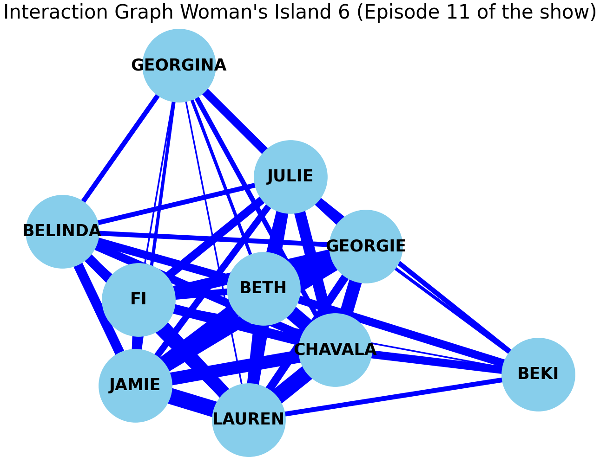

##### Figure 5.1

| Mens Interaction Graph | Average Degree Centrality |
| --- | --- |
| Episode 1: | 0.6703296703296704 |
| Episode 3: | 0.6703296703296703 |
| Episode 5: | 0.9454545454545454 |
| Episode 7: | 0.9454545454545454 |
| Episode 10: | 0.8727272727272730 |
| Episode 12: | 0.9555555555555555 |
| Combined Episodes | 0.9670329670329672 |

##### Figure 5.2

| Womens Interaction Graph | Average Degree Centrality |
| --- | --- |
| Episode 2: | 0.7142857142857143 |
| Episode 4: | 0.4871794871794871 |
| Episode 6: | 0.7272727272727272 |
| Episode 8: | 0.8000000000000000 |
| Episode 9: | 0.9333333333333332 |
| Episode 11: | 0.9333333333333332 |
| Combined Episodes | 0.9340659340659342 |

##### **Figure 6.1**

| Mens Interaction Graph | Average Clustering Coefficient |
| --- | --- |
| Episode 1: | 0.8558286951144094 |
| Episode 3: | 0.8188775510204082 |
| Episode 5: | 0.9452380952380953 |
| Episode 7: | 0.9525252525252526 |
| Episode 10: | 0.9109668109668108 |
| Episode 12: | 0.9523809523809523 |
| Combined Episodes | 0.9674825174825175 |

##### **Figure 6.2**

| Womens Interaction Graph | Average Clustering Coefficient |
| --- | --- |
| Episode 1: | 0.7949546485260771 |
| Episode 3: | 0.7371794871794872 |
| Episode 5: | 0.8425685425685424 |
| Episode 7: | 0.8839105339105338 |
| Episode 10: | 0.9428571428571428 |
| Episode 12: | 0.9500000000000000 |
| Combined Episodes | 0.9418054168054167 |

##### **Figure 7.0**

| **Men** | **Women** |
| --- | --- |
| **Figure 7.1.1** | **Figure 7.2.1** |
|  |  |
| **Figure 7.1.2** | **Figure 7.2.2** |
|  |  |
| **Figure 7.1.3** | **Figure 7.2.3** |
|  |  |
| **Figure 7.1.4** | **Figure 7.2.4** |
|  |  |
| **Figure 7.1.5** | **Figure 7.2.5** |
|  |  |
| **Figure 7.1.6** | **Figure 7.2.6** |
|  |  |

##### **Figure 8.1**

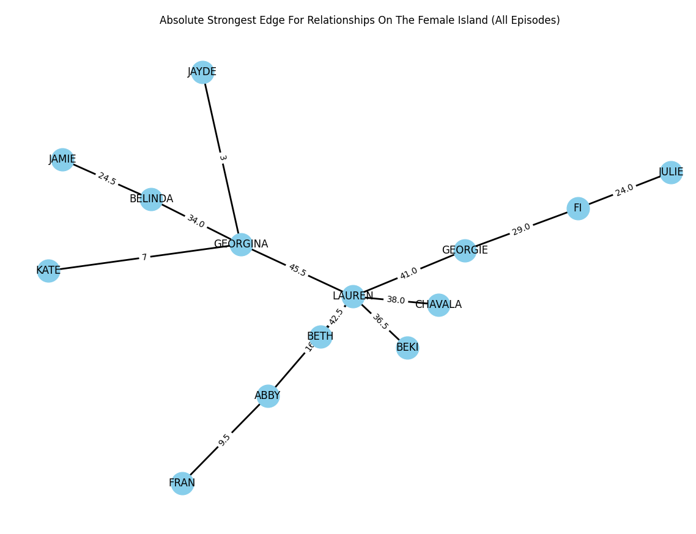

##### **Figure 8.2**

